ISP Overview
The image signal processor (ISP) module of Sirius supports standard sensor data processing. The ISP module provide basic function such as auto white balance(AWB),automatic exposure(AE),de-mosaic, defected pixel correction(DPC) as well as advanced functions such as wide dynamic range(WDR),dynamic range compression(DRC),both RAW de-noise and 3D de-noise.

Features
- Black level correction(BLC)
- Static and dynamic DPC and defect pixel cluster correction
- Bayer denoising
- Advanced demosaic
- Gamma Correction
- DRC
- Color management and enhancement
- Sensor Build-in WDR
- Alternate row HDR
- AWB
- AE
- AF
- 3A(AE,AF,AWB) statistics output
- Lens shading correction(LSC)
- Picture Sharpening
- Color Noise correction
- Digital Zoom
- Linear correction
- Anti-aliasing
- Contrast Enhancement
- Support YUV444/YUV420 10bit/8bit Input
- Support de-purple
- Support 3D-denoise
- Max Support 3 Resolution Output

The processing capability of the ISP module is as follows：
- Maximum 14bit Bayer data input
- Maximum picture resolution of 8100*8100
- Minimum picture resolution of 480*240
- Maximum frame of 60 fps for the 3840*2160
- Minimum H blank region of 128 pixels
- Minimum V blank region of 30 lines
- Support real-time processing multi sensor input
- Support low-latency processing

TOP Diagram
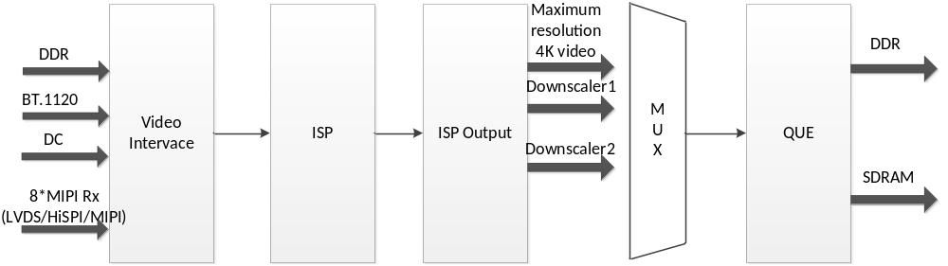
Figure 1 Functional block diagram of the ISP module

4. ISP Processor Performance
The ISP Module supports the following operating modes:
- Maximum 14-bit raw RGB Bayer data input
When the data width is less than 14bits, the upper bits need to be aligned and the lower bits need to be stuffed with 0s. In this mode, any sequence of R,Gr,Gb and B components is supported, and the sequence can be changed by configuring CFG_REG1.
- Supports YUV422/YUV444 8bit Video Input
- Support Raw data input from Video Interface Line Buffer
  - Maximum resolution of 4312*2176 for single sensor video input
  - Maximum resolution of 1920*1088 for two sensor video input
- Support Data input from DDR
- Maximum resolution of 8100*8100 for picture processing
  - Support real-time processing multi sensor video input
for example：4K@30fps+720P@60fps+720P@60fps
- Maximum support 3 resolution video output，maximum 1920*1080 for second resolution and maximum, maximum 640*480 for third resolution
- Adjustable statistics positions

